Employee Management System

1. Prerequisites
Before running the application, ensure the following are installed and configured:
- Java 17 or higher
- Maven (or use the included mvnw wrapper)
- MySQL Server running on port 3306
- A database named training created in MySQL
Database Setup Command: CREATE DATABASE training;
The application will automatically create the employee table on the first run.

2. Running the Application
- Open a terminal in the project root folder.
- Run the following command: .\mvnw.cmd spring-boot:run
- Wait for the console to show: Started WebBasedApplication in X.XXX seconds.
- The server is now live at http://localhost:8080.

3. Opening the Web Interface
Open any web browser and navigate to: http://localhost:8080 The login page will load automatically.

4. Logging In
The application has two built-in accounts:
Username | Password | Role | Access Level
admin | admin123 | Admin | Full access (all features)
user | user123 | User | View employees only
Steps:
- Enter your username and password.
- Click Sign In.
- On success, the dashboard will display your username and a role badge (Gold "ADMIN" or Plain "USER").
Login Page
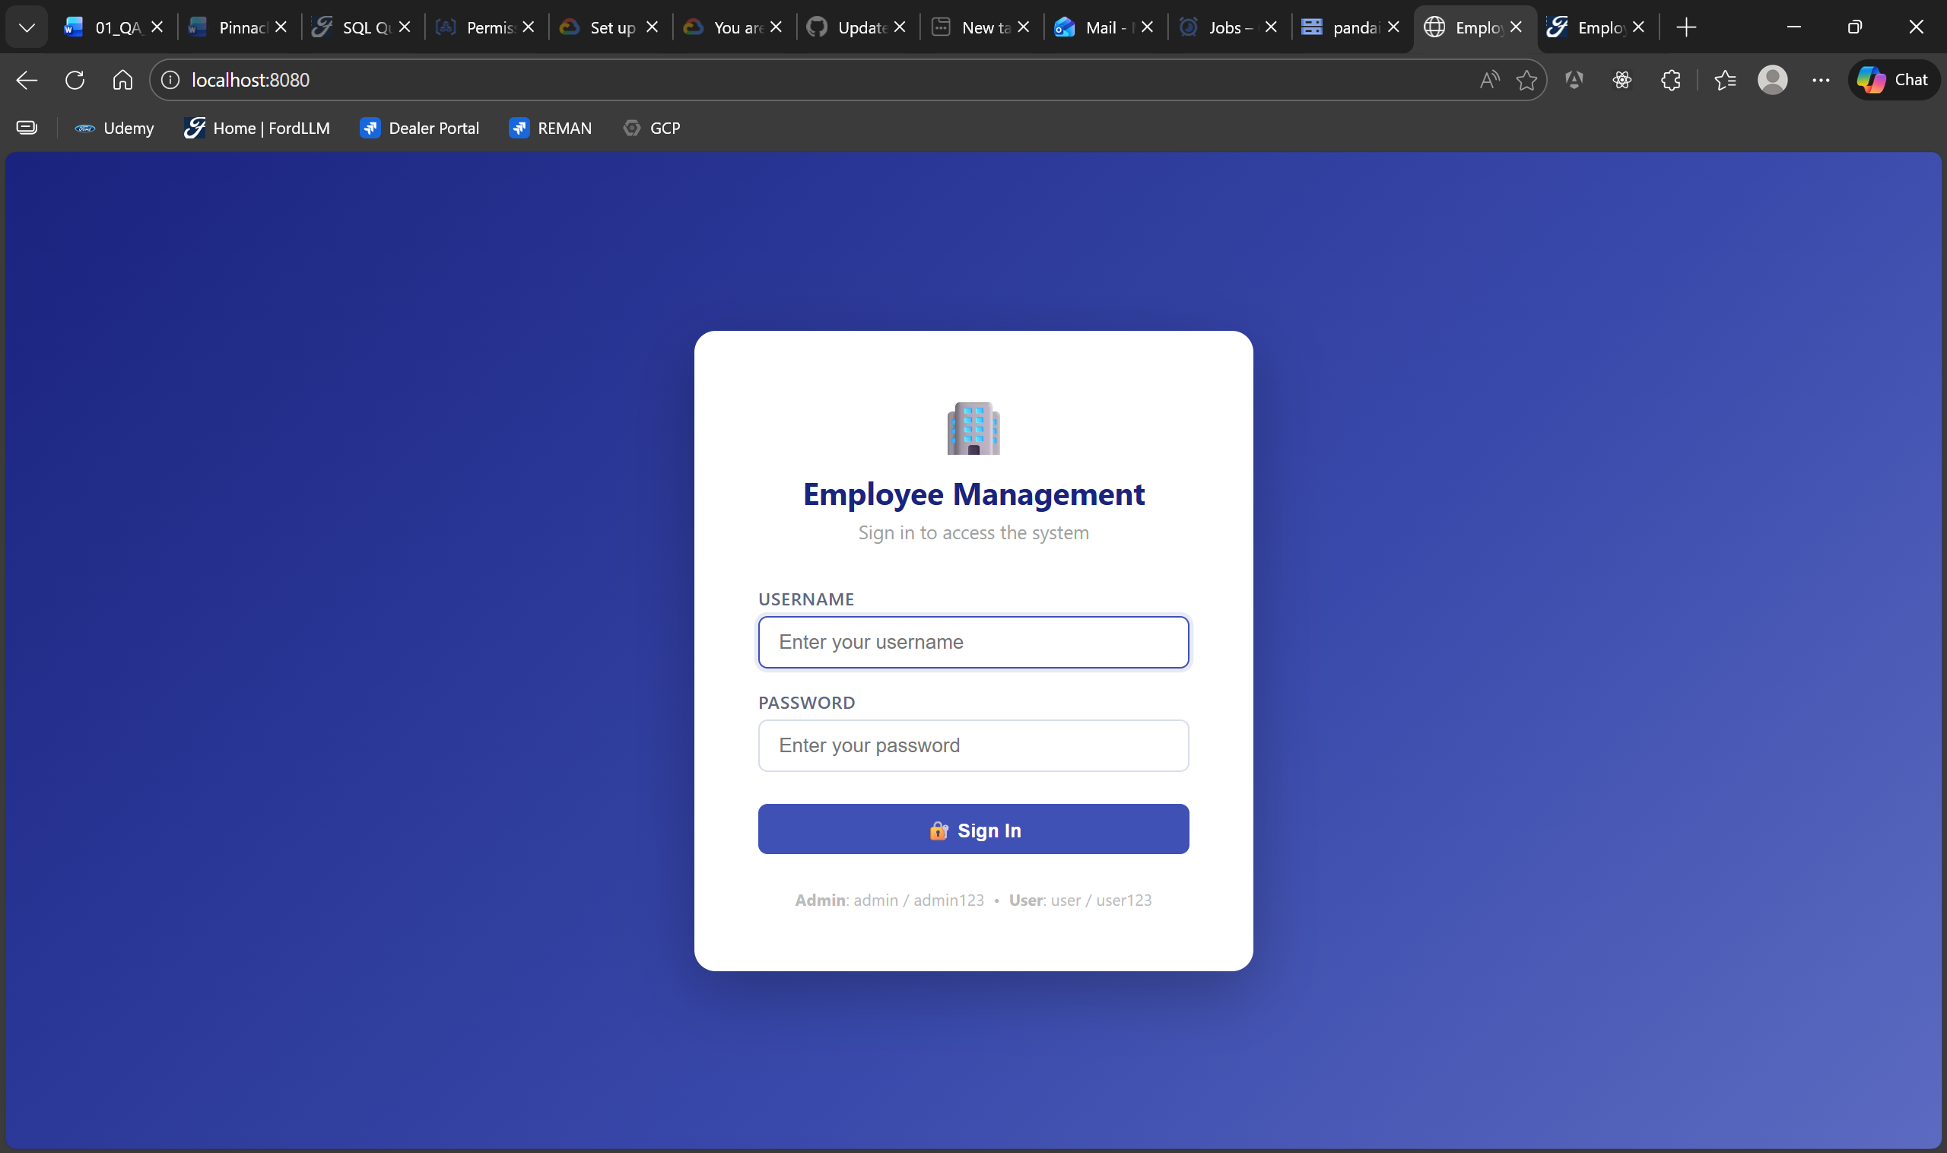
Backend Failed State
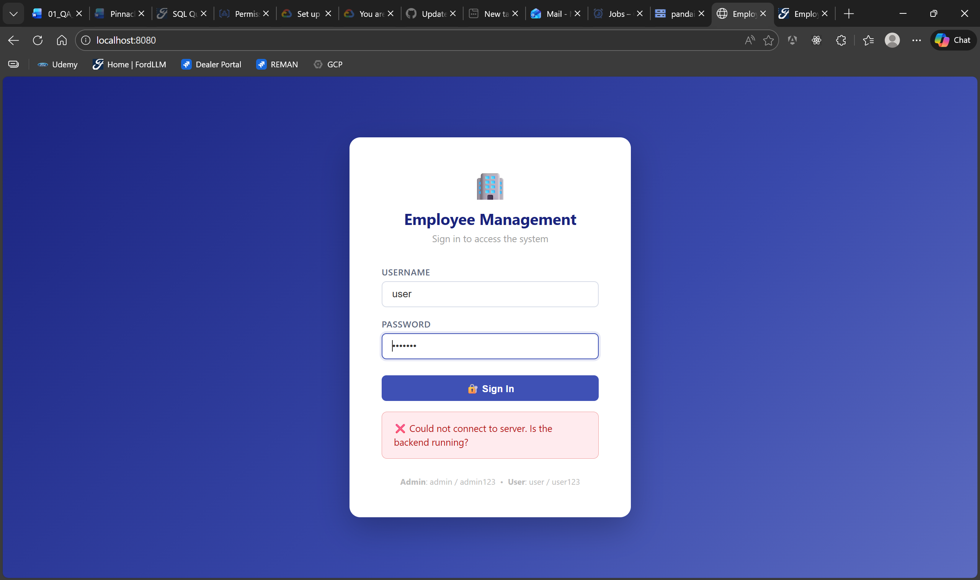

User Sign In
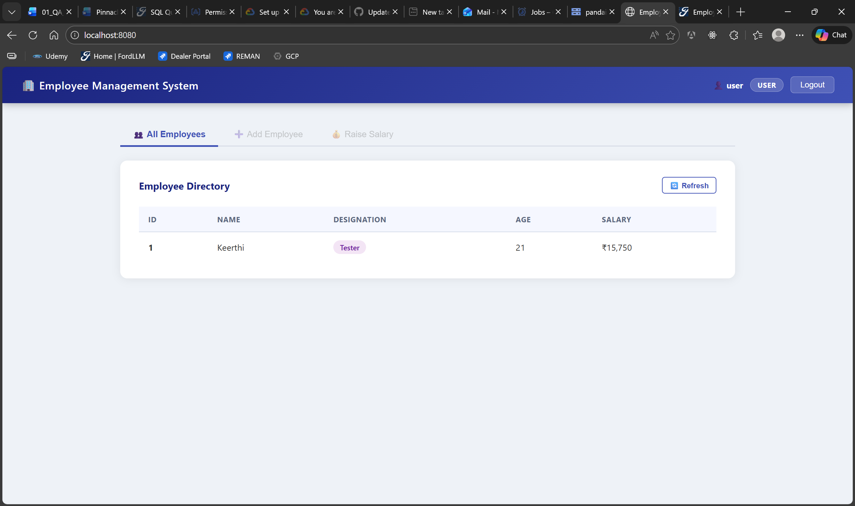
Admin Sign In
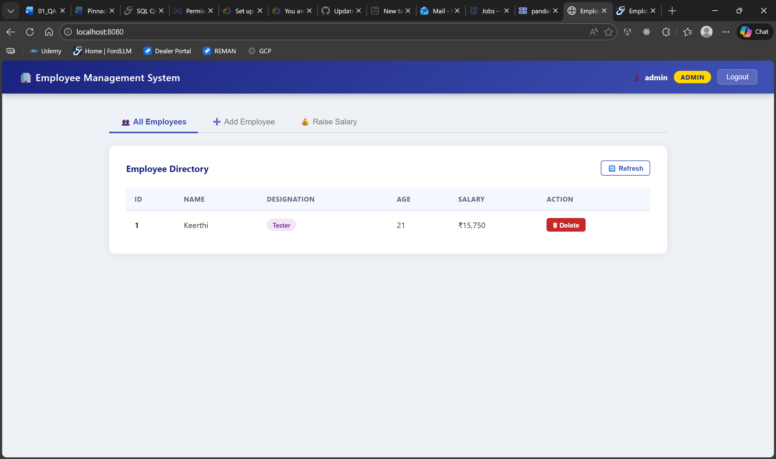

5. Viewing Employees
The All-Employees tab is the default view.
Column | Description
ID | Auto-generated unique identifier
Name | Full name of the employee
Designation | Blue (Programmer), Purple (Tester), Green (Manager)
Age | Employee age in years
Salary | Current salary in Indian Rupees (INR)
Action | Delete button (Visible to Admin only)

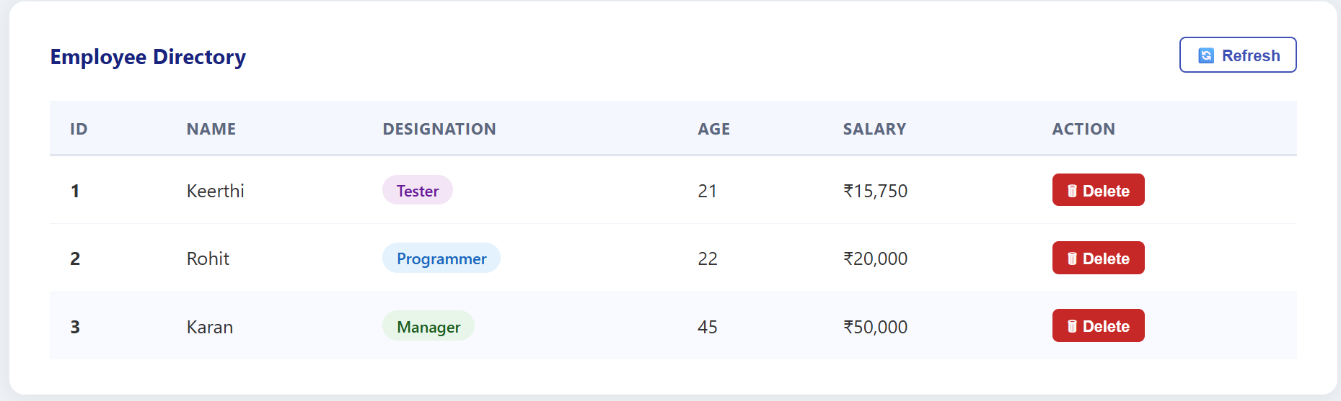

6. Adding an Employee
(Admin role required)
- Click the Add Employee tab.
- Full Name: Letters and spaces only (max 2 spaces).
- Designation: Select Programmer, Tester, or Manager.
- Age: Whole number between 19 and 60.
- Click Add Employee.
Automatic Salary Assignment:
- Programmer: Rs. 20,000
- Tester: Rs. 15,000
- Manager: Rs. 50,000
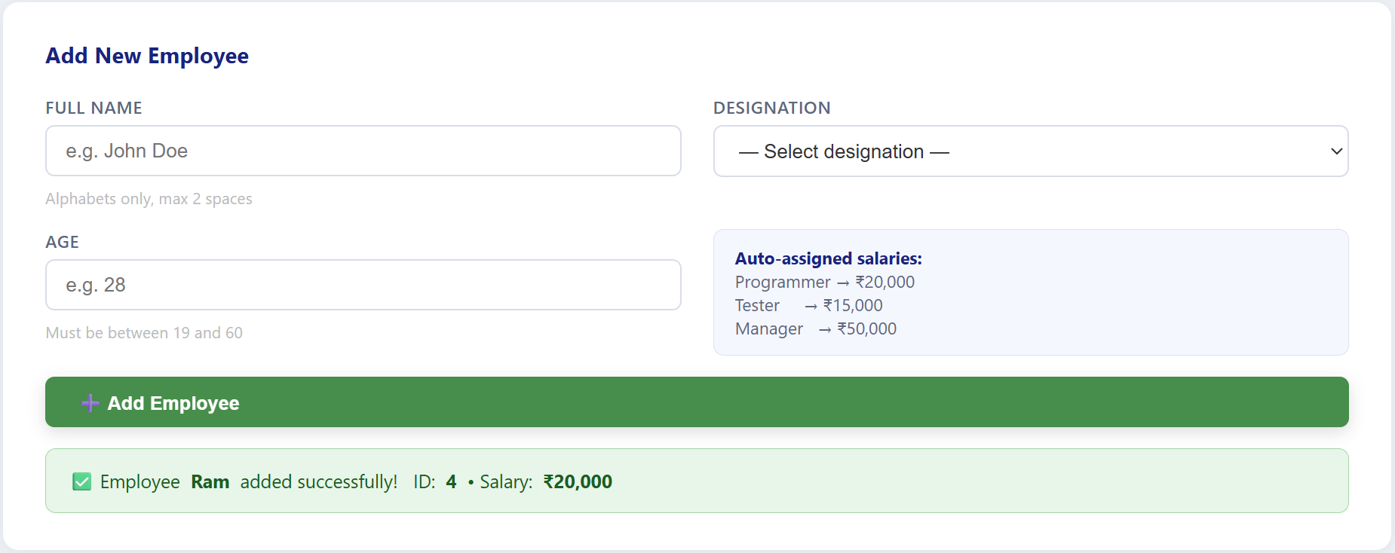

7. Raising a Salary
(Admin role required)
- Click the Raise Salary tab.
- Employee Name: Search is case-insensitive.
- Raise Percentage: Whole number between 1 and 10.
- Click Apply Raise.
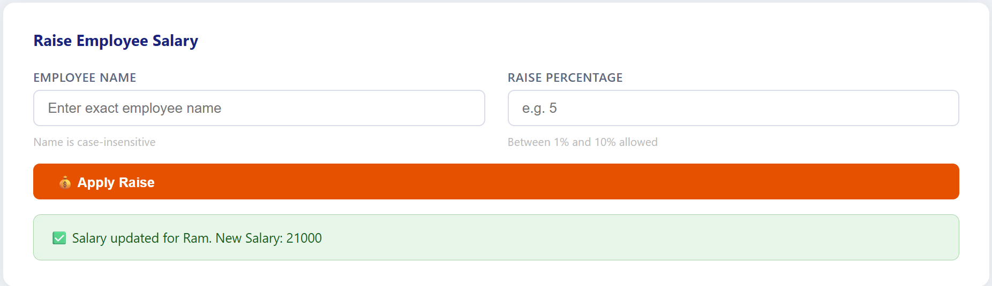

8. Deleting an Employee
(Admin role required)
- In the All Employees tab, locate the employee.
- Click the Delete button.
- Confirm the action in the pop-up dialog. Note: If the table becomes empty, the ID counter resets to 1.
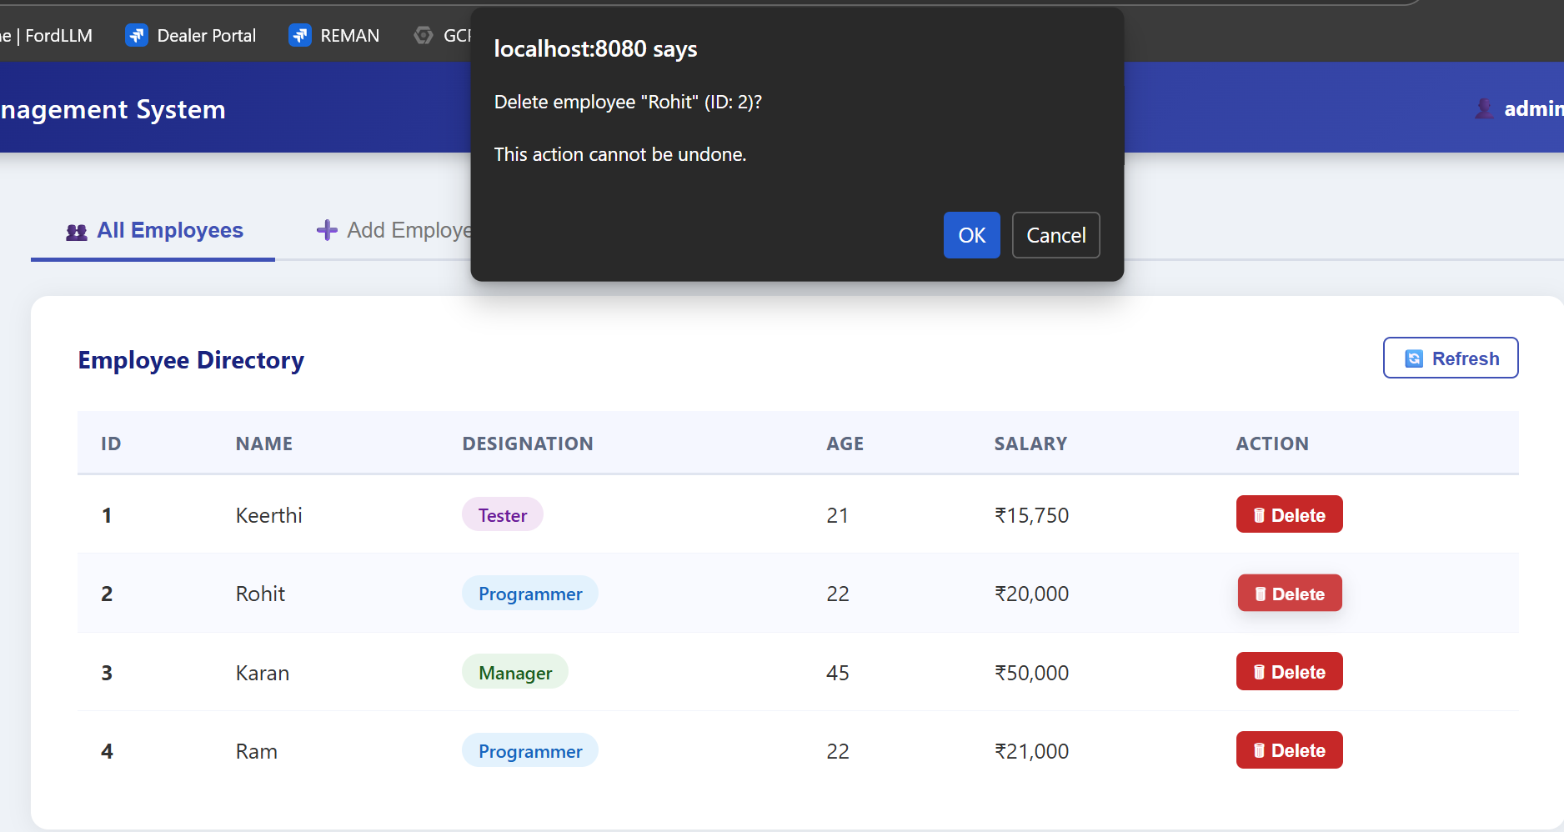
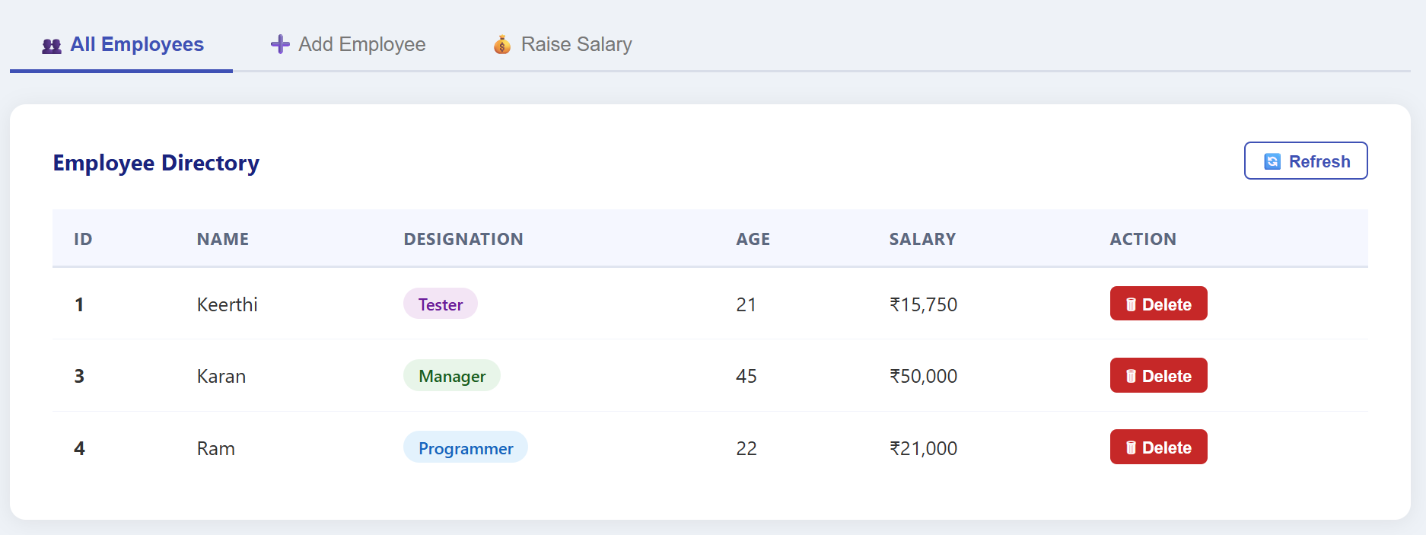

9. User Roles and Permissions
Feature | Admin | User
View all employees | Yes | Yes
Refresh employee table | Yes | Yes
Add Employee tab | Yes | No (disabled)
Raise Salary tab | Yes | No (disabled)
Delete button in table | Yes | No (hidden)

10. Validation Rules
Field | Rule | Rejected Example
Name | Letters only, max 2 spaces | John_Doe, Mary Jane Watson Lee
Designation | Must be Programmer, Tester, or Manager | Developer
Age | Whole number 19 to 60 | 18, 61
Raise % | Whole number 1 to 10 | 0, 11

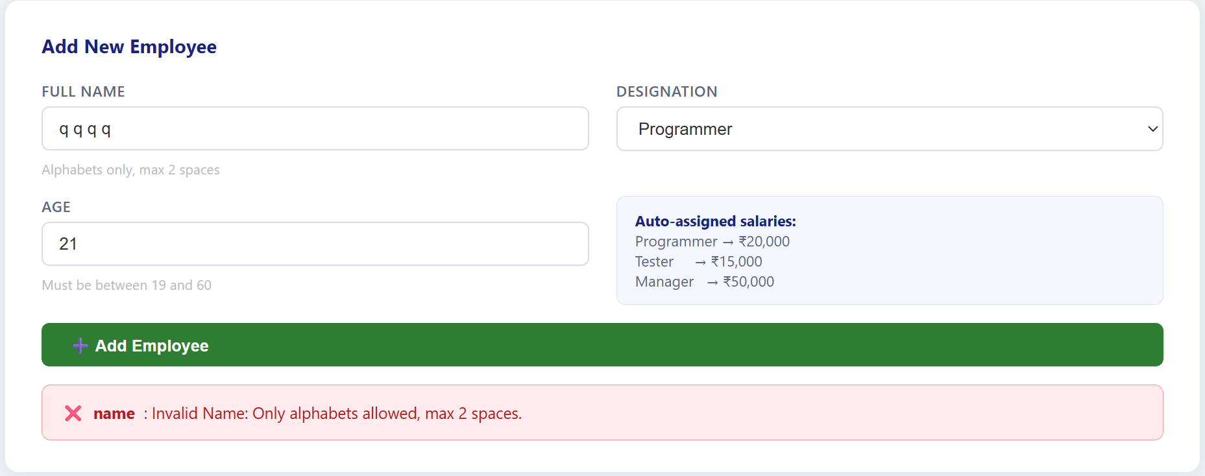
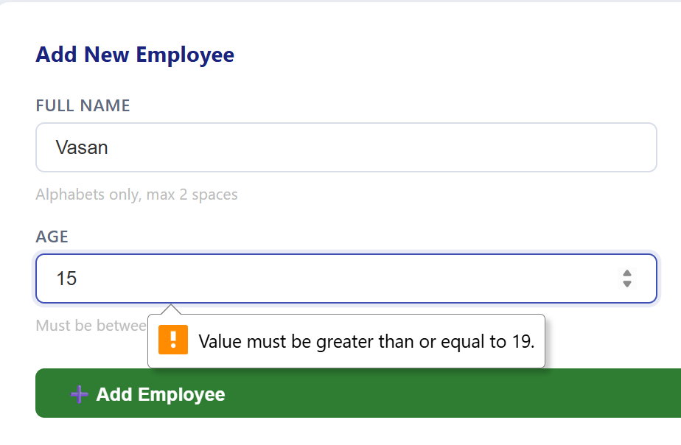

11. Error Messages Reference
Login & Connection
- Invalid username or password: Credentials do not match.
- Could not connect to server: Spring Boot application is not running.
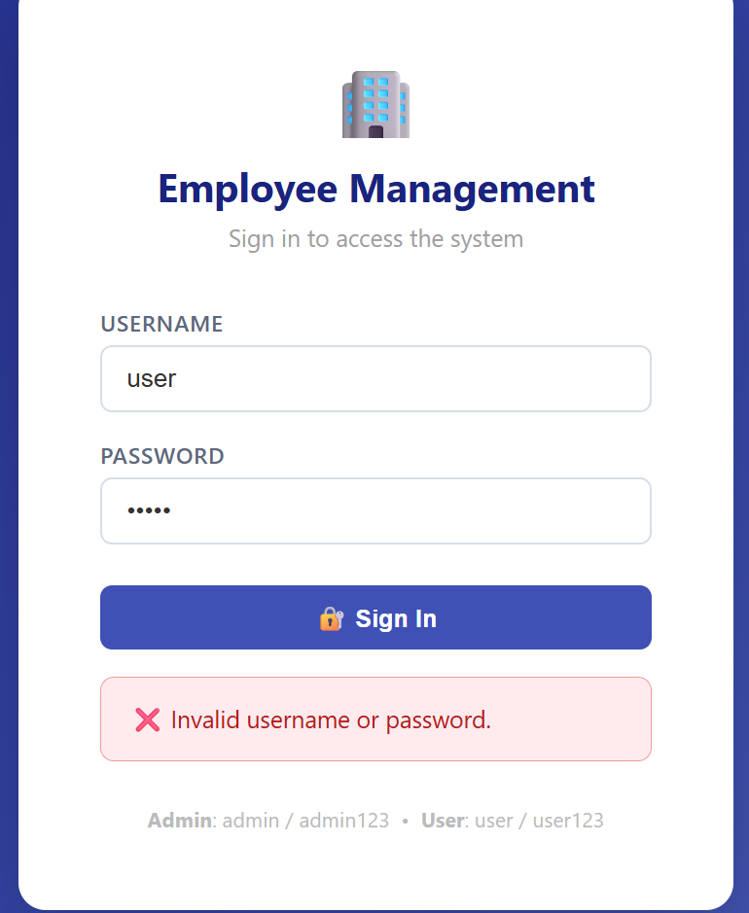
Add Employee Errors
- Name must not be blank: Field submitted empty.
- Invalid Name: Contains numbers, symbols, or 3+ spaces.
- Invalid Age: Outside the 19–60 range.
- Access denied: Attempted action without Admin role.
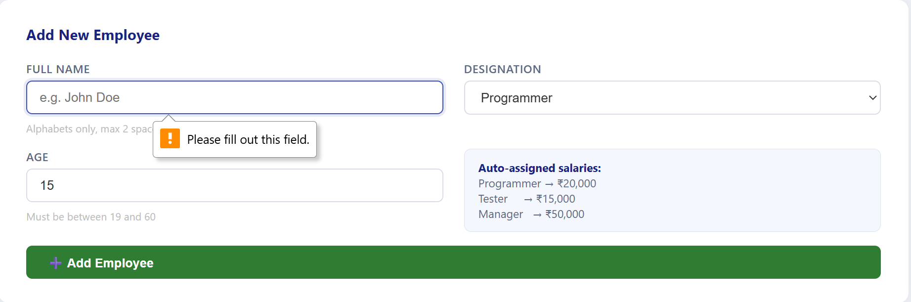
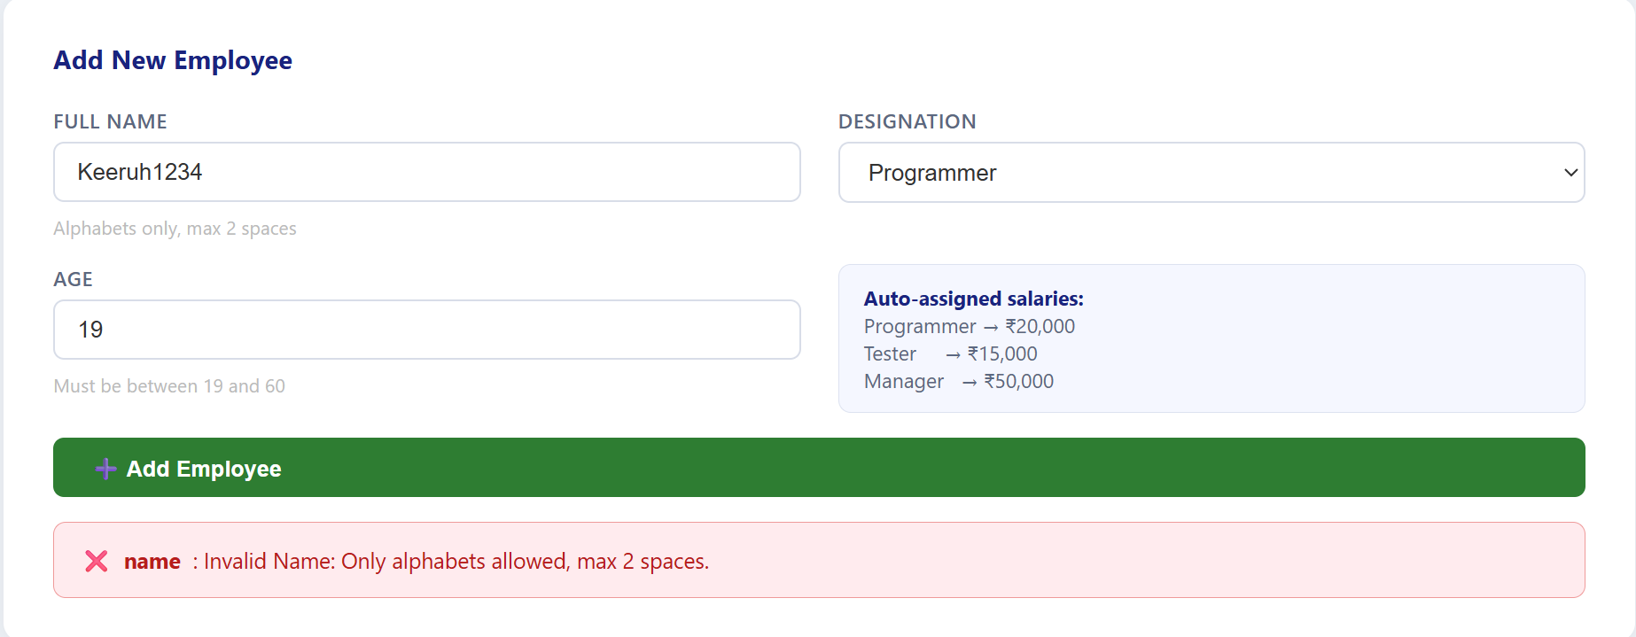
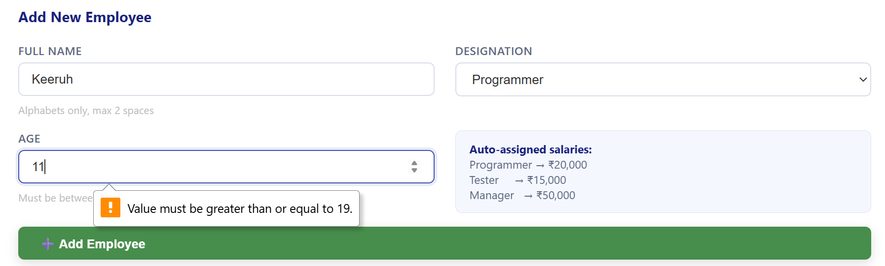

Raise Salary Errors
- Employee not found: No match for the name entered.
- Max Allowed Raise is 10%: Value entered was 0 or above 10.
